Northwind Outdoor Ltd.
High-Level Design (HLD)
IT Infrastructure Modernisation Project

Document Control
Version | Date | Author | Description | Status
V0.1 | 16.09.2026 | Redstone Consulting | Initial High level design draft | Internal Draft

Approval
Approval Status: Pending Northwind Approval
Business Approvers | Approval Status
Northwind IT Manager | Pending
Northwind Operations Director | Pending

Executive Summary
Redstone Consulting proposes a modernised, centrally governed, secure, and scalable IT infrastructure for Northwind Outdoor Ltd. This design addresses the organisation’s key business drivers: improving operational efficiency, strengthening security and resilience, and enabling sustainable future growth.
The proposed architecture uses a standardised and centrally managed infrastructure model, with security and operational controls applied consistently across services. Resilience is primarily recovery-led, with redundancy introduced selectively where service criticality and agreed recovery objectives justify the additional complexity and cost.
The architecture establishes standardised infrastructure services, improved identity and access management, structured network segmentation, secure file and data services, robust backup and recovery capabilities, and a controlled operational model. It supports Northwind’s critical business systems while providing a foundation for future expansion, automation, and additional business capabilities.
This HLD defines the solution direction, architectural principles, and domain-level design which is designed to address the requirements established within the approved BRD and associated RTM baseline—without prescribing specific technologies, products, or vendors.

Purpose & Scope
This High-Level Design (HLD):
- Defines the proposed future-state architecture for Northwind’s modernised IT environment.
- Aligns all architectural components with the approved Business Requirements Document (BRD v1.0) and the Requirements Traceability Matrix (RTM).
- Provides customer-facing descriptions of design decisions, architectural principles, and domain-level solution direction.
- Establishes the foundation for subsequent Low-Level Designs (LLDs), Statements of Work (SoWs), implementation planning, and testing.
- Defines what the proposed architecture will provide and the principles governing its design; detailed implementation specifications, configuration parameters and build procedures are deferred to subsequent LLDs and implementation documentation.
In Scope
- The HLD addresses the twelve agreed architecture domains covering
  - Network
  - Compute & Platform
  - Identity & Access
  - Core Infrastructure Services
  - Application & Business Services
  - Storage
  - Backup & Recovery
  - Security
  - Observability
  - Management & Operations
  - Integration
  - Resilience & Availability

Detailed Design Boundary
Detailed product selection, host sizing, IP addressing, VLAN configuration, storage allocation, firewall rules, package selection, service configuration and build procedures are outside the scope of this HLD and will be defined through subsequent LLDs, Statements of Work and implementation documentation.

Out of Scope (v1)
- Broad deployment of High Availability clustering and active/active service architectures. Selective redundancy may be introduced where justified by approved service-criticality and recovery requirements.
- Enterprise-scale directory/federated identity platforms beyond the approved v1 identity and access model.
- Advanced automation frameworks.
- Second-site DR architecture (future consideration aligned with Northwind’s 3–5 year growth plan).
Business & Design Context
The architecture is shaped by key drivers, constraints, assumptions, and NFRs documented in the BRD and RTM. The proposed architecture has been developed in response to the business drivers, requirements, constraints, assumptions and non-functional requirements established during discovery and documented within the approved BRD and associated RTM.
Key Drivers
- Operational Efficiency — Improve the consistency, manageability and efficiency of IT operations.
- Security & Resilience — Strengthen protection of business systems and information while improving Northwind's ability to recover from disruption.
- Sustainable Growth — Establish an infrastructure foundation capable of supporting anticipated growth in users, data and business services.
Constraints
- Service Continuity — Disruption to existing business-critical services during migration and implementation shall be minimised, with planned service interruptions subject to agreed change and maintenance arrangements.
- Cost & Resource Proportionality — Available budget, infrastructure capacity and operational resources require resilience measures to be proportionate to business criticality rather than applying HA universally.
- Existing Service Integration — The proposed architecture must remain compatible with required existing business systems and workflows.
Assumptions
- Northwind will provide accurate asset baselines.
- Recovery Objectives — Service-specific RTO and RPO requirements will be confirmed by Northwind before detailed recovery and resilience designs are finalised.
- Northwind will participate in UAT and design reviews.
Important NFRs Shaping the Architecture
- Availability – proportionate resilience.
- Security – defence in depth.
- Recoverability – recovery-led resilience.
- Observability – monitoring and logging.
- Operational Consistency — standardised and repeatable administration to reduce variation and human error.
- Scalability – managed growth.

Architecture Principles
The following architectural principles have been applied consistently when evaluating design options and establishing the proposed solution.
- Standardisation — Use consistent build patterns, configuration standards and operational processes wherever practical to reduce complexity, configuration drift and administrative error.
- Recovery-Led Resilience — Prioritise reliable and tested recovery as the baseline resilience model, introducing redundancy and High Availability where justified by service criticality and recovery objectives.
- Security by Design — Apply defence in depth, least privilege, segmentation and host-level controls throughout the architecture rather than treating security as a separate downstream activity.
- Automation Where Appropriate — Automate stable and repeatable operational activities where doing so reduces administrative effort and human error, while retaining appropriate control, documentation and recoverability.
- Managed Growth — Design infrastructure so that users, data, workloads and services can grow without requiring disproportionate redesign or premature enterprise complexity.
- Controlled Change — Infrastructure changes should be documented, tested where practical, approved where required, verifiable and recoverable.
- Supportability — Infrastructure shall be designed so that Northwind's IT team can operate, maintain and troubleshoot it using appropriate documentation, procedures, monitoring and knowledge transfer.

Proposed Solution Overview
Northwind’s future-state architecture is a centrally governed infrastructure platform providing secure, resilient, and scalable services.
The architecture consolidates Northwind’s core infrastructure and business services onto a standardised virtualised compute platform, supported by segmented network services, controlled identity and administrative access, structured storage, backup and recovery, and central operational visibility. The design adopts recovery-led resilience as its baseline, with additional redundancy introduced selectively where justified by service criticality and agreed recovery objectives.
High-Level Architecture Summary
- Compute & Platform: A standardised virtualised server environment providing compute resources for core infrastructure and supported business services, with separation between production and testing/sandbox workloads.
- Identity & Access: A standardised identity and access model providing named user identities, role-appropriate access, controlled privilege elevation and consistent joiner/mover/leaver administration across supported Linux services.
- Network: A segmented network architecture separating user, server/infrastructure, management/administration and external/untrusted environments, with controlled communication between security zones.
- File/Data: Secure file services providing structured departmental data organisation, controlled access and compatibility with required user workflows.
- Storage: Logically separated persistent storage supporting controlled allocation, capacity expansion and recovery requirements for hosted services and business data.
- Backup/Recovery: Layered backup and recovery capabilities providing automated protection, secondary copies outside the primary failure domain, scheduled restoration testing and documented recovery procedures.
- Security: Defence-in-depth controls incorporating network segmentation, host-level security enforcement, strong authentication, controlled administrative access, patch governance and security-relevant logging and monitoring.
- Observability: Central monitoring and alerting combined with native system diagnostic capabilities, supported by local and selected centralised logging, historical performance information and operational reporting.
- Remote & Administrative Access: Controlled remote access separating ordinary business access from privileged administration, with named identities, strong authentication, controlled privilege elevation and auditable administrative activity.
- Management & Operations: Standardised administration, controlled software and patch lifecycles, documented operational procedures and automation of appropriate repeatable activities.

High-Level Architecture Diagram
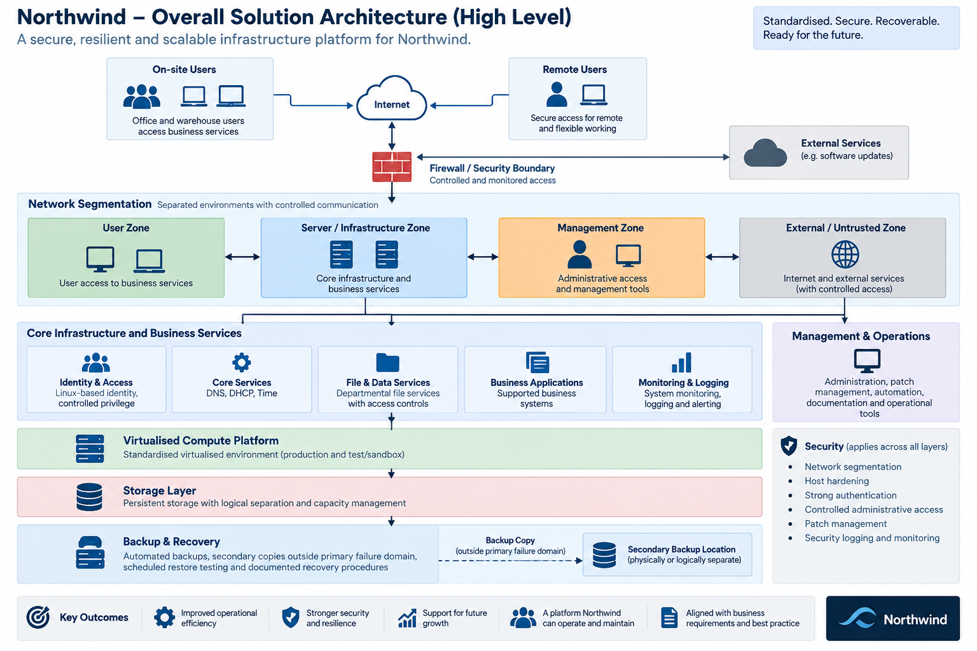
- Overall Solution Architecture

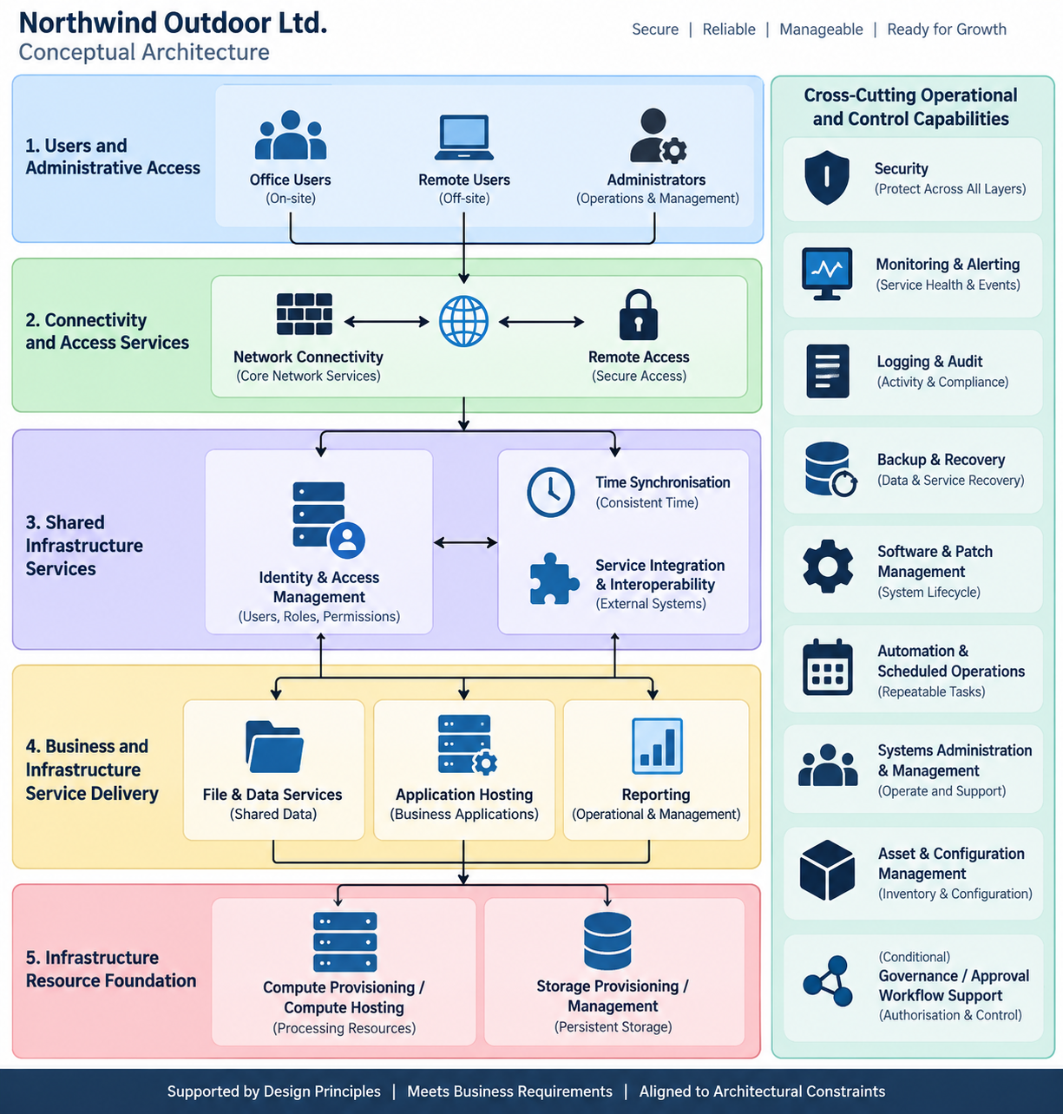
- Conceptual Architecture

- Network & Access Architecture
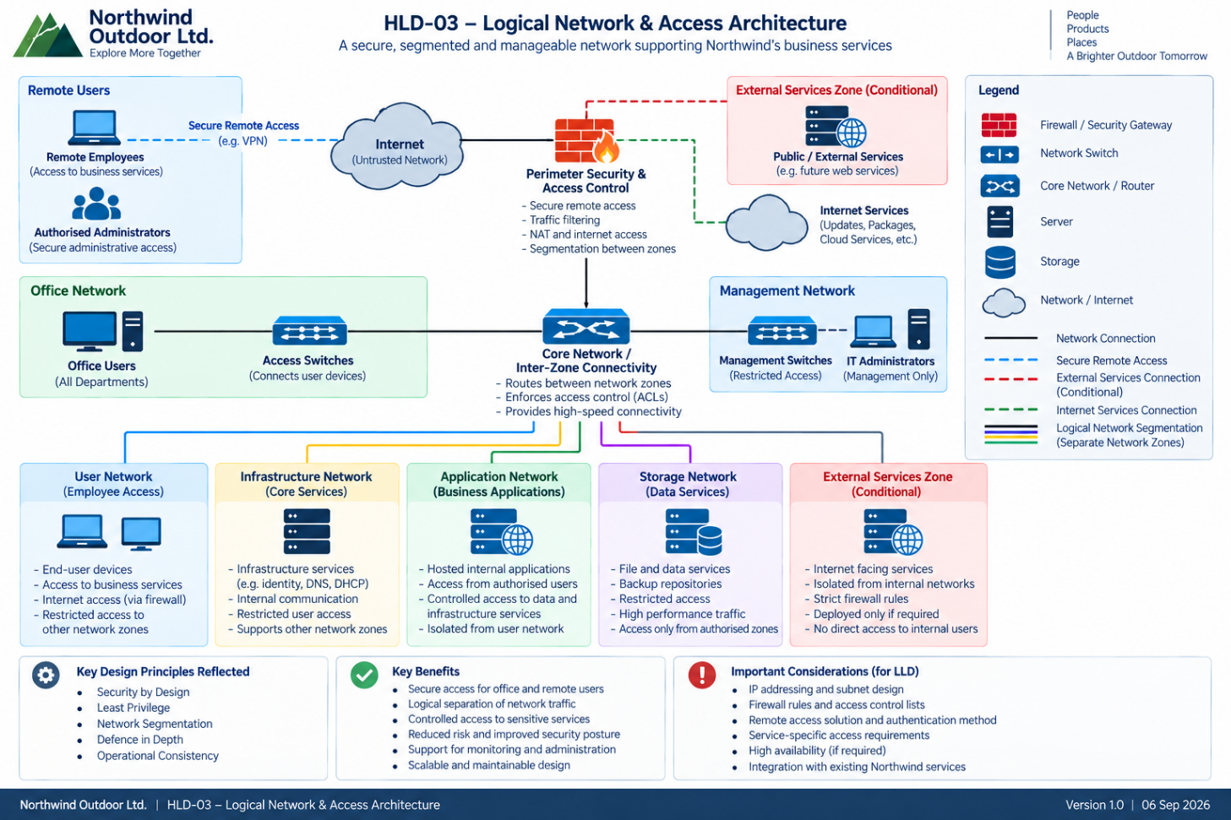

- Compute, Storage & Service Infrastructure
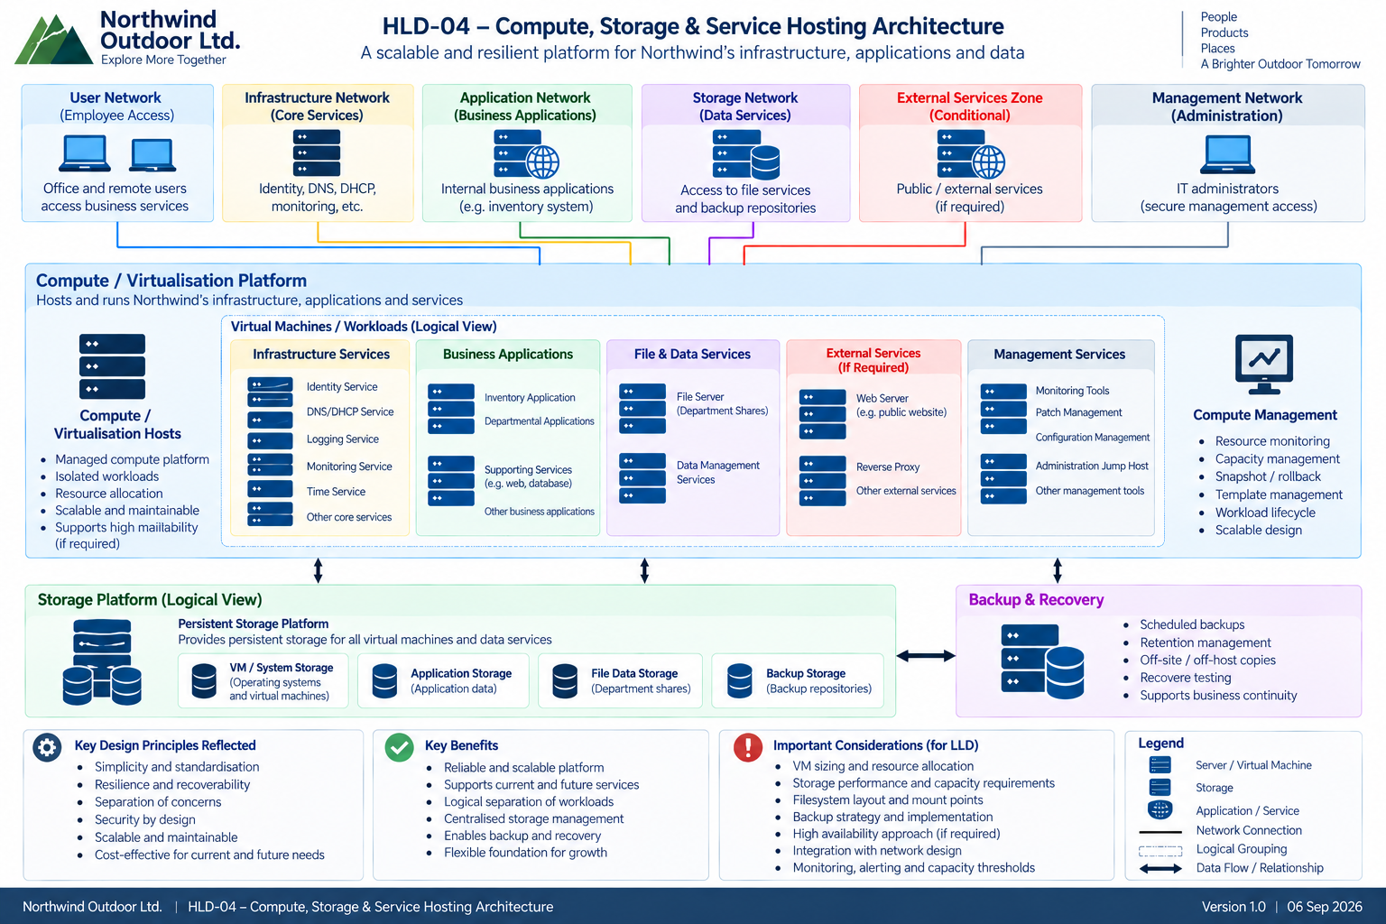

- Operations, monitoring & Recovery
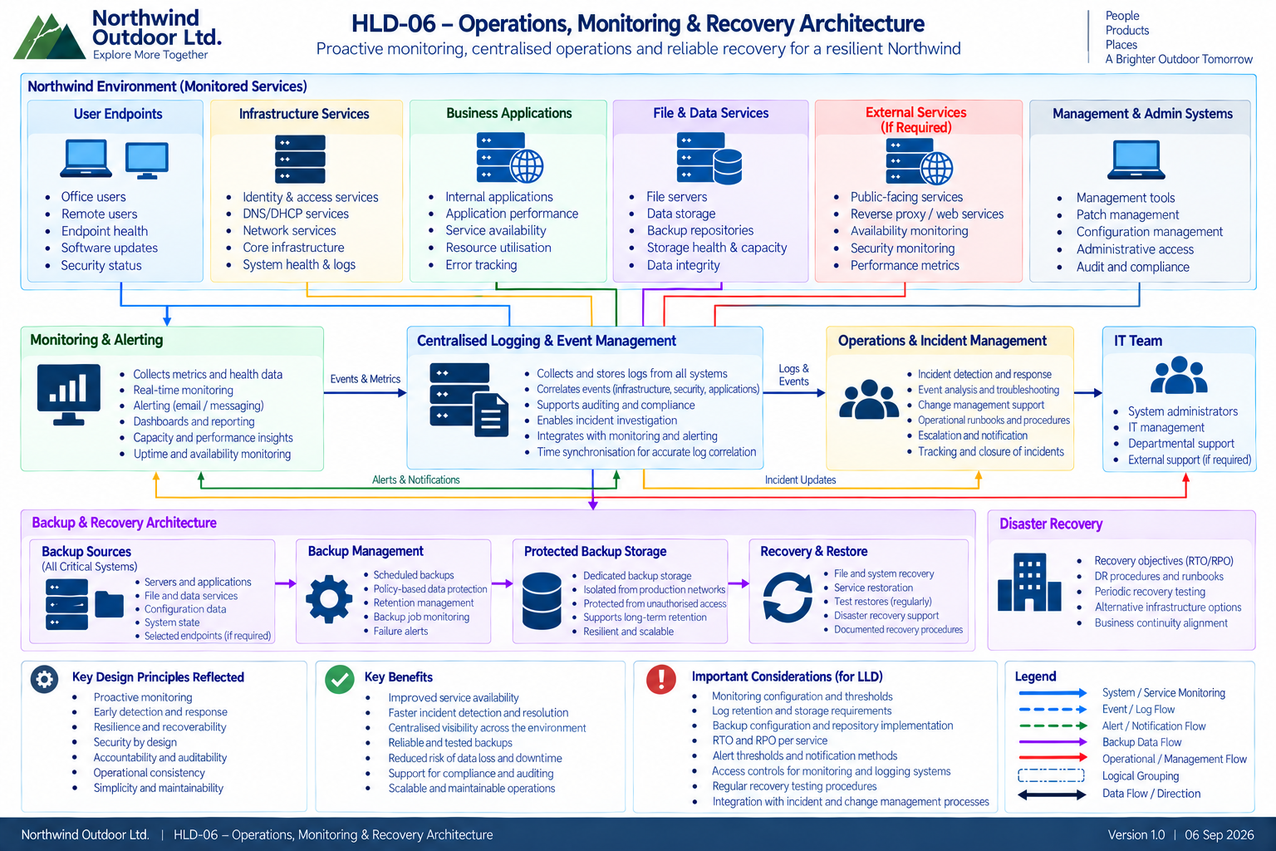

- Identity, Security & Administration
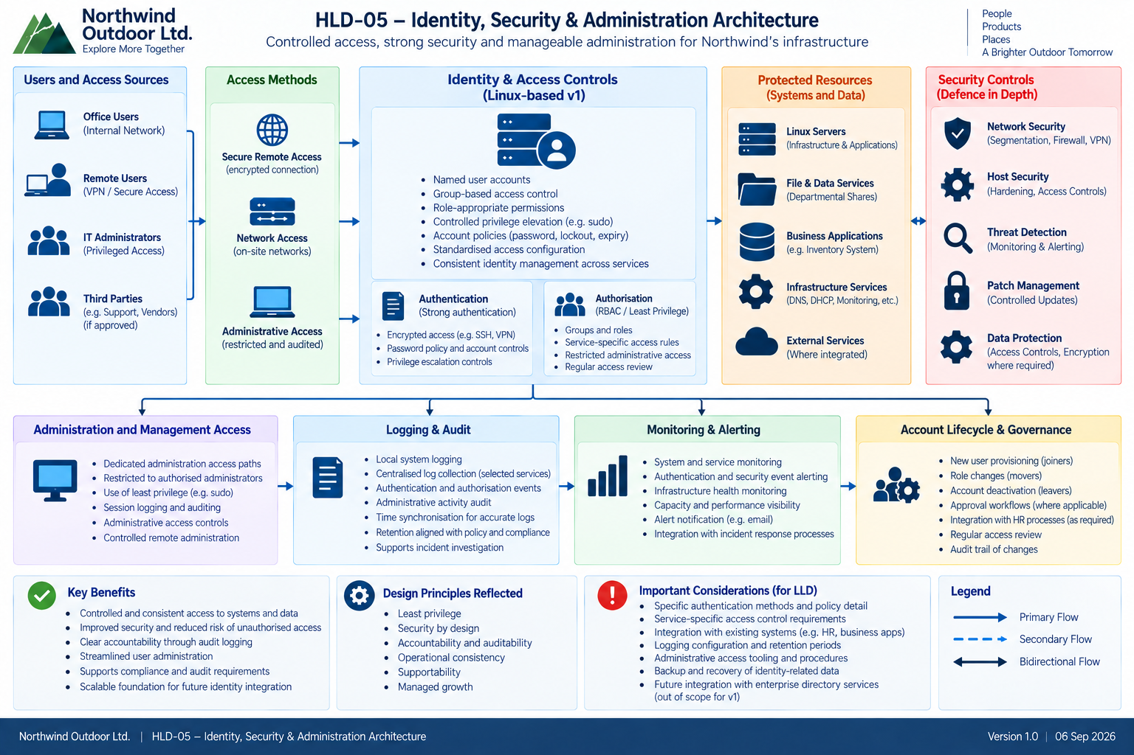

Architecture by Domain
AD-01 Network Architecture
- Segmented network design separating user, warehouse, server, and management environments.
- Firewall boundaries enforcing least privilege.
- Secure remote access with strong authentication.
- Centralised routing and core network services.
AD-02 Compute & Platform Architecture
- Virtualised server environment.
- Standardised operating system baselines.
- Sandbox/testing environment for updates and changes.
AD-03 Identity & Access Architecture
- Centralised identity and access management.
- Role-based access aligned with departmental responsibilities.
- Controlled joiner/mover/leaver workflows.
- Separation of privileged and non-privileged access.
AD-04 Core Infrastructure Services
- Centralised DNS, DHCP, and time synchronisation.
- Standardised configuration and governance.
AD-05 Application & Business Services
- File services, printing, internal applications.
- Warehouse Inventory System hosted on dedicated infrastructure.
- Integration with existing business systems.
AD-06 Storage Architecture
- Logical storage pools.
- Departmental shares with structured organisation.
- Capacity/performance visibility.
AD-07 Backup & Recovery Architecture
- Automated backups.
- Scheduled restore testing.
- Recovery procedures aligned with RTO/RPO.
- Recovery-led resilience model.
AD-08 Security Architecture
- Defence in depth.
- Network segmentation.
- Host hardening.
- Strong authentication for remote and administrative access.
- Logging and threat detection.
AD-09 Observability Architecture
- Centralised logging.
- Monitoring and alerting for critical services.
- Capacity/performance reporting.
AD-10 Management & Operations Architecture
- Controlled administrative access.
- Patch management with pre-production testing.
- SOPs, runbooks, recovery procedures.
AD-11 Integration Architecture
- Integration with existing business systems.
- Future integration capability preserved.
AD-12 Resilience & Availability Architecture
- Recovery-led resilience.
- Selective redundancy where justified.
- HA evaluated but not committed for v1.

Key Design Decisions (DD-001 to DD-012)
DD-001 – Compute / Virtualisation
Decision: Use a virtualised compute platform. Rationale: Supports standardisation, scalability, and controlled operations. Consequence: Enables structured deployment and future resilience options.
DD-002 – Network Segmentation
Decision: Introduce segmented network architecture. Rationale: Supports least privilege, security, and resilience. Consequence: Reduced blast radius for incidents.
DD-003 – Identity & Access Model
Decision: Centralised IAM with RBAC. Rationale: Supports business requirements for security and governance. Consequence: Clear separation of duties and controlled access.
DD-004 – Time Synchronisation
Decision: Centralised time synchronisation service. Rationale: Supports logging, authentication, monitoring. Consequence: Consistent timestamps across infrastructure.
DD-005 – File & Data Services
Decision: Departmental shares with structured organisation. Rationale: Supports usability and access control. Consequence: Improved data governance.
DD-006 – Storage Architecture
Decision: Logical storage pools with growth planning. Rationale: Supports scalability and capacity management. Consequence: Predictable storage lifecycle.
DD-007 – Backup & Recovery
Decision: Automated backups + scheduled restore testing. Rationale: Supports recoverability and business continuity. Consequence: Recovery confidence and documented procedures.
DD-008 – Security Architecture
Decision: Defence in depth + host hardening. Rationale: Supports security requirements. Consequence: Reduced risk of compromise.
DD-009 – Logging & Monitoring
Decision: Centralised logging and monitoring. Rationale: Supports observability requirements. Consequence: Improved visibility and troubleshooting.
DD-010 – Management & Operations
Decision: Controlled admin access + patch testing. Rationale: Supports operational stability. Consequence: Reduced operational risk.
DD-011 – Integration
Decision: Maintain compatibility with existing business services. Rationale: Supports continuity. Consequence: No disruption to current workflows.
DD-012 – Resilience Model
Decision: Recovery-led resilience; selective redundancy. Rationale: Balances cost, complexity, and business impact. Consequence: Predictable recovery without unnecessary HA.

Security Architecture
The security model applies defence in depth across identity, network, host, application, and operational layers.
Key Components
- Least privilege access.
- Segmentation of networks and services.
- Strong authentication for remote and administrative access.
- Host hardening.
- Logging and audit trails.
- Threat detection and alerting.
- Patch governance and controlled change.

Availability, Backup & Recovery
Northwind’s resilience model prioritises recoverability over unnecessary HA.
Availability
- Proportionate resilience based on business impact.
- Selective redundancy for critical services.
Backup
- Automated backups with retention aligned to business needs.
- Backups stored on dedicated infrastructure.
Recovery
- Scheduled restore testing.
- Documented recovery procedures.
- Service-specific RTO/RPO confirmed during LLD.

Operations & Support Model
Operational Capabilities
- Monitoring and alerting.
- Centralised logging.
- Patch management with testing.
- Administrative automation (where appropriate).
- SOPs, runbooks, recovery procedures.
- Controlled change management.
Responsibilities
- Northwind IT: day-to-day operations.
- Redstone: design, implementation, knowledge transfer.

Scalability & Future Growth
The architecture supports Northwind’s 5-year growth plan:
- Additional users, departments, and workloads.
- Future second warehouse.
- Additional automation and integration.
- BI, supplier portals, customer self-service portals.
Future capabilities are clearly separated from v1 scope.

Requirements Traceability Summary
The architecture has been assessed against all BRD and NFR requirements. Full traceability is maintained within the RTM. This HLD satisfies the functional and non-functional requirements defined in BRD v1.0.

Risks, Assumptions, Constraints & Dependencies
Key Risks
- Incomplete asset baseline.
- Recovery objectives requiring additional investment.
- Limited monitoring in current environment.
Key Assumptions
- Northwind provides accurate baseline information.
- UAT participation is available.
Key Constraints
- Budget may limit HA adoption.
- Existing systems impose integration constraints.
Dependencies
- Asset inventory baseline.
- Confirmation of RTO/RPO.
- Access to existing systems.

Deferred / Future Considerations
- High Availability clustering.
- Enterprise IAM.
- Advanced automation frameworks.
- Second-site DR architecture.
- Additional security tooling.
- BI and analytics platforms.
These are not part of v1 scope but are supported by the architecture.

Approval & Next Steps
Approval
Northwind Outdoor Ltd. will review and approve this HLD before detailed design begins.
Next Steps
- HLD approval.
- Development of LLDs and Statements of Work.
- Implementation planning.
- Controlled deployment and testing.
- Operational handover.

